**FIGURES**

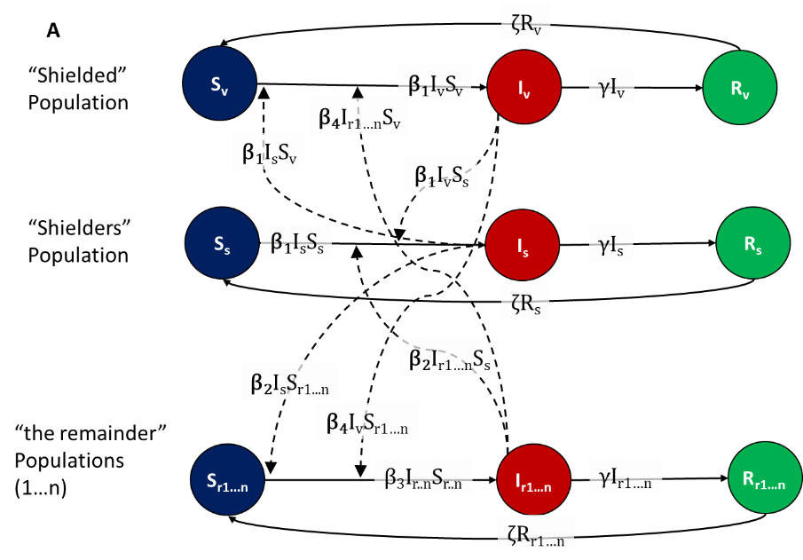

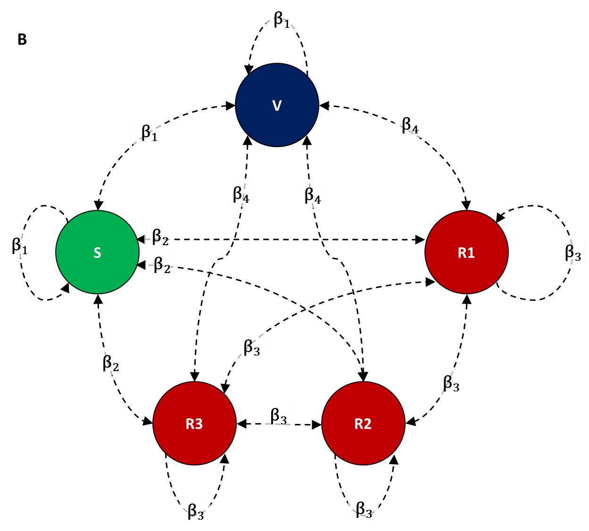

**Figure 1** - The SIRS model structure (A) defined by Susceptible, Infectious and Remainder compartments and (B) the 20-20-20-20-20 network structure with five equal sized populations: vulnerable (V), shielders (S) and three remainder populations (R1, R2 and R3). This illustrates the baseline with five equal sized populations, but can be extended to n equal sized populations by increasing the number of remainder subpopulations. We define four values of the rate of transmission (β) with β1 defining the rate of transmission within and between the vulnerable and shielders; β2 defines transmission between shielders and remainders; β3 defines transmission between the remainder populations and β4 defines transmission between remainder and vulnerable populations. Infectious compartments recover at rate γ and recovered compartments lose immunity at rate ζ.

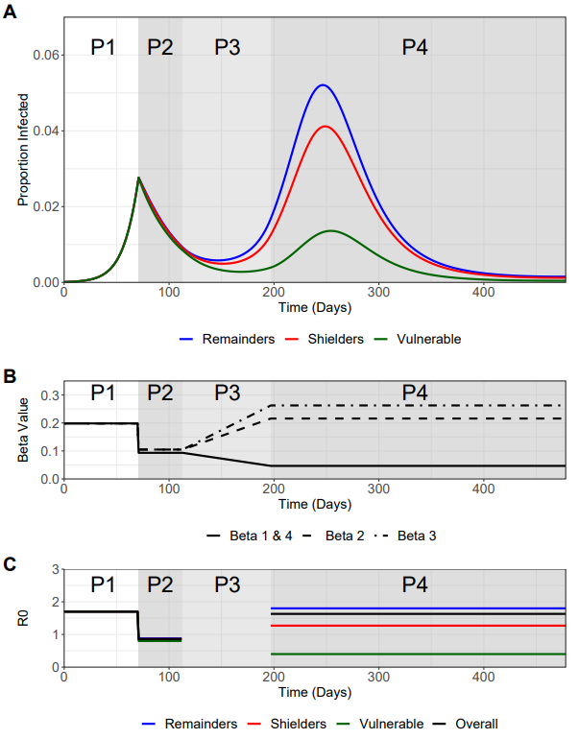

**Figure 2 – Baseline “Central Analysis” + Beta and R0 plots**

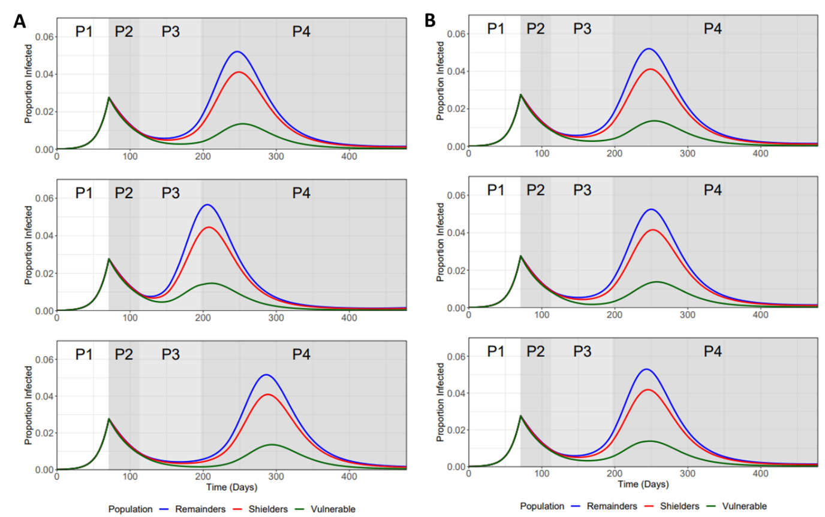

**Figure 3 – Ramp up vs Ramp Down sensitivity Analysis**

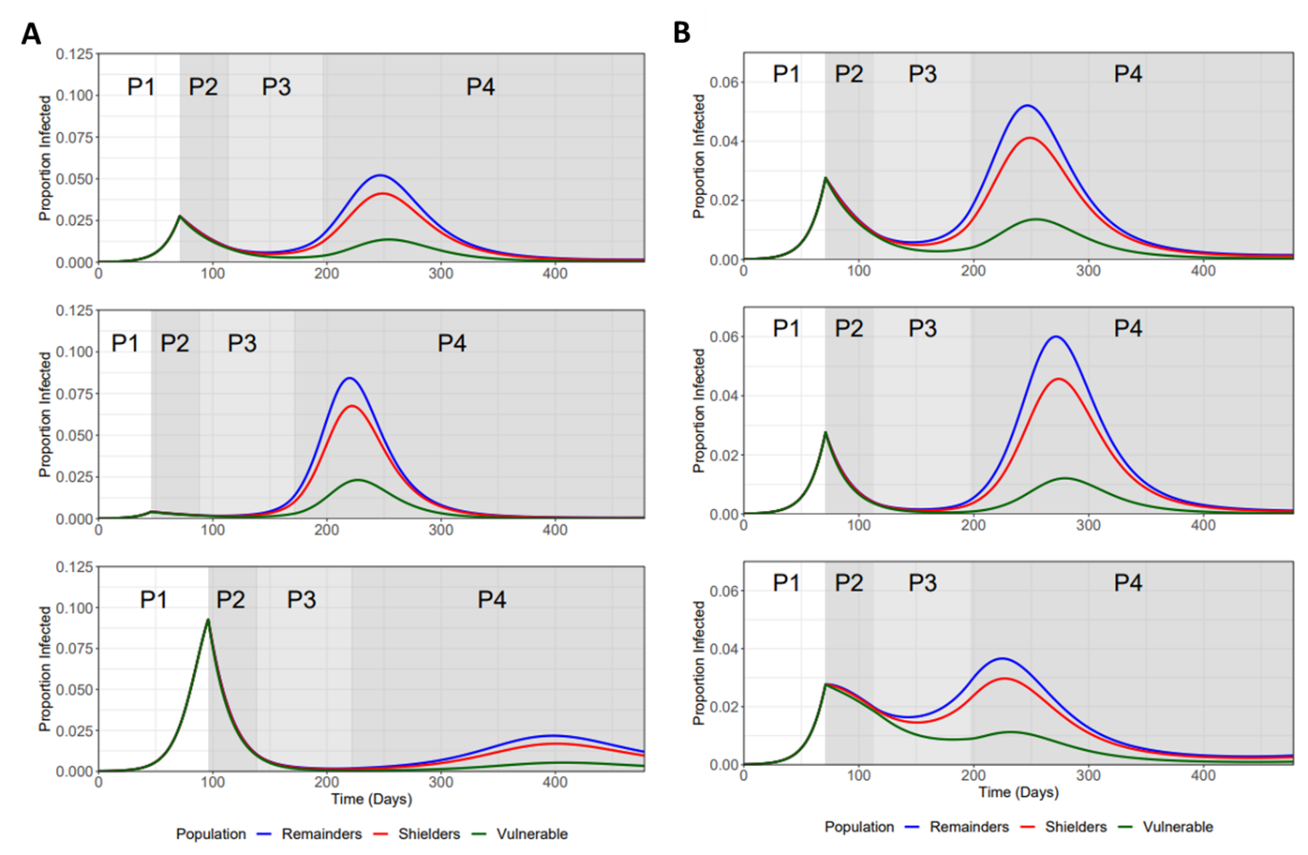

**Figure 4 - Sensitivity Analysis for Trigger Point and Phase 2 Betas**

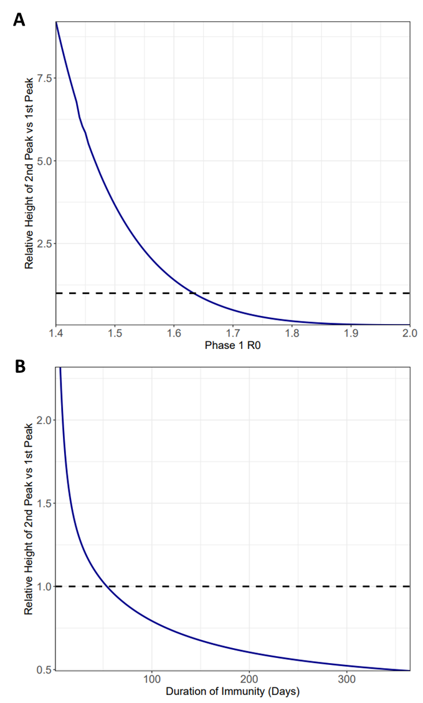

**Figure 5 – Variation in Phase 1 Beta and Zeta values (expressed in 1/zeta) on the relative height of 2nd peak vs 1st peak.**

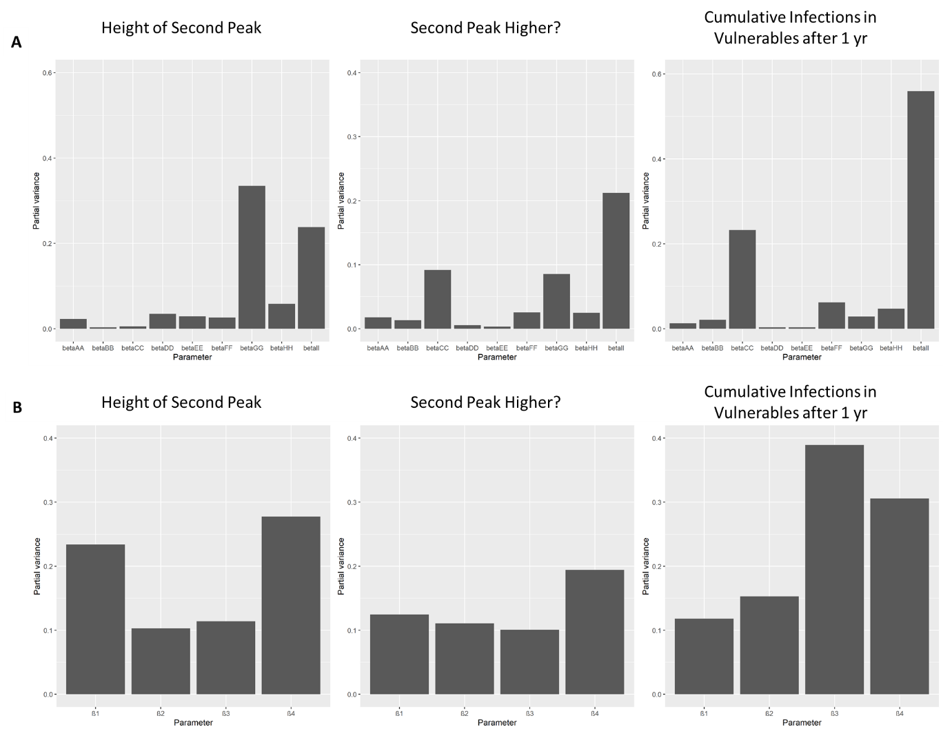

**Figure 6 –** Results of a global sensitivity analysis on three key epidemic measures with regards the proportion of the vulnerable population that become infected (Iv): 1) the height of the second peak of Iv; 2) whether the second peak of Iv is higher than the first peak and 3) cumulative Iv one year after the start of the lockdown. The bars show the partial variance of the individual model parameters. Higher bars indicate greater sensitivity of the model to that parameter.

The results clearly show that it is beta_II and β3 (parameters that determine transmission between the non-vulnerable populations) that will be key to determining the size of epidemic that affect the vulnerable population. See Material and methods section for details about the sensitivity analysis and parameter ranges used.

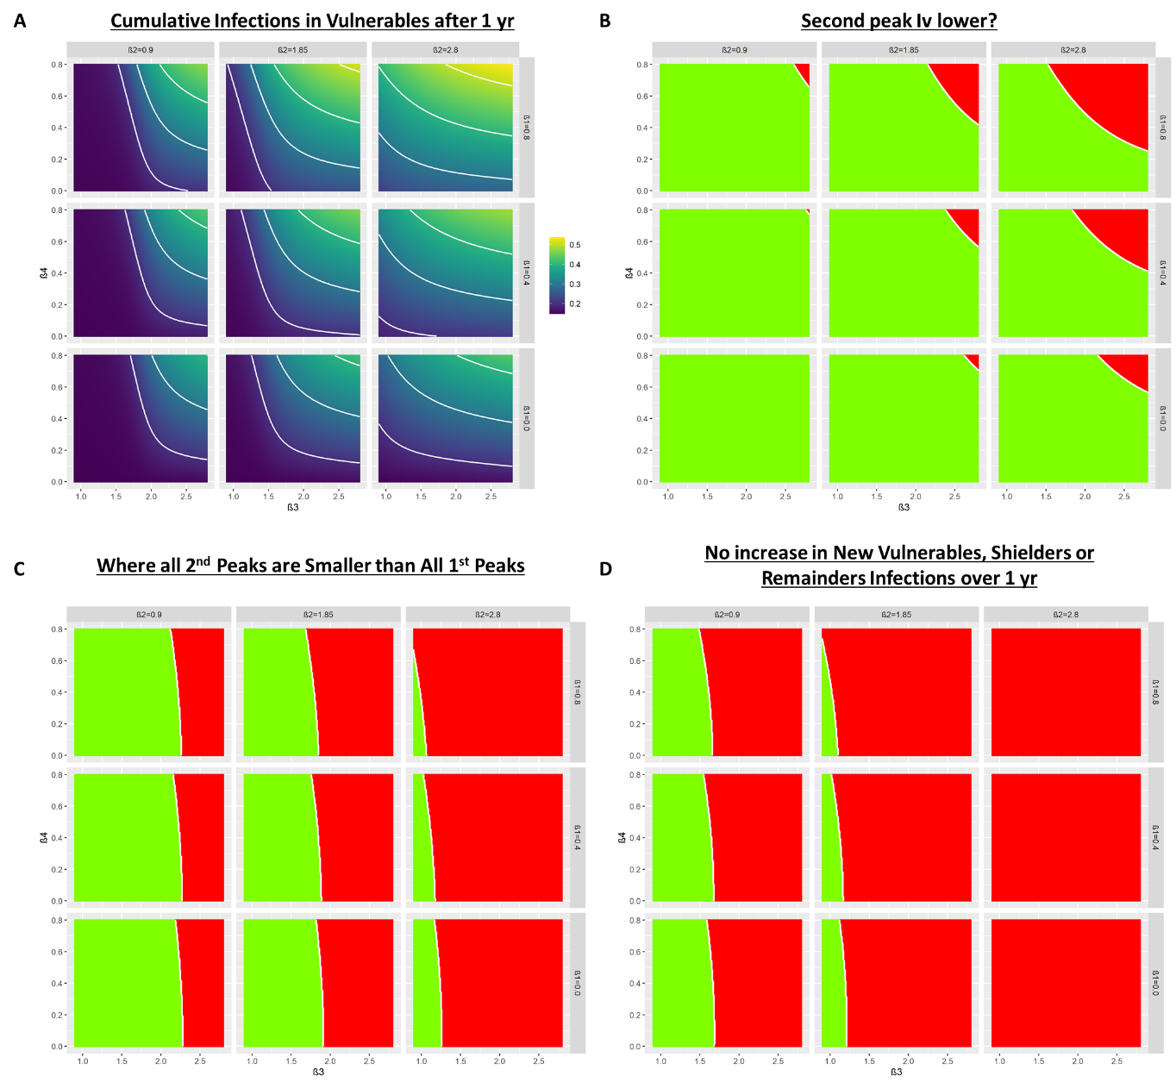

Figure 7. Heat maps showing the trade-offs between relaxation and protection. A) Each subplot depicts a heat map showing the cumulative fraction of the vulnerable population that become infected (Iv) one year after the start of lockdown for different combinations of β3 & β4 for different values of β1 (rows) and β2 (columns). B) As A) but for whether the second peak of is lower (green) or higher (red) than the first peak. C) As (B) but all 2nd peaks (Iv,Ih & Ir) smaller than 1st peaks (green). D) As (B) but dI­/dt negative or zero for at least 365 days after the start of lockdown for all I-compartments.